MY CRYPTO TRADING COOK BOOK
By Vinayaka Amaresh

Income Strategies
- Selling NFTs – still an unchartered territory
- HODLING alt coins – buy and forget – check after 5 years. (Check my Cryptos excel sheet)
- Crypto Arbitrage – low risk but requires quick action and decision making – is a trading strategy that exploits the price differences of an asset.
- Invest in BTC, Ethereum and Litecoin – slow returns but promised returns.
- Playing NFT games like MOM NFT Farmer – like locking in your money and collecting dividends, tokens and selling them as NFTs.
- Owning a small miner hardware setup at your home to mine the cryptos.
- Algo Trading – TBD
Trading Strategies
- Volatility and securing profits – due to crypto market’s volatile nature, its always good to take profits when you think you got a ROI. Whatever comes up in a short period of time, it has to come down to consolidate and to fill the price gap. So, if you see such a chart, better book profits and you can enter later. May be you can take 60% of the equity and leave 40% of it there to further grow/fall. But will eventually grow over the time.
- Lotto Plays – Its always good to buy some lottery tickets in Crypto and who knows. You can win big. There are 1000s of Meme coins out there that flourish and fade every day. If you time well, you can make decent chunk of money. On an average, if you invest $200 early at the start of the meme coin, it may give you 100x returns. So, once in a while, you can play lottery. But don’t over-allocate due to greed. You might as well lose everything. So, be prepared and invest what you can afford to lose.
- Crypto market is wild – When the bear market unveils, its pretty upsetting. When crash happens, Crypto market beats the coins and tokens pretty badly. There will be usually 30% to 60% downfall. Every coins will follow the trail of BTC. BTC is like Crypto’s Dow-Jones, S & P 500. If BTC fall, all other falls. So, plan your strategy accordingly. When you see every one is greedy and buying, you should remain fearful and feel free to take some profits. And when everyone is selling, you buy and be greedy. This works best and help you reach your financial goal early. Also, you might need to check NUPL (Net Unrealized Profit/Loss) chart of BTC. It helps you to navigate different stages of the crypto market and see where you are yourself. As you might know, every market has layers of emotions. Capitulation (Surrender) -> Hope (Fear) -> Optimism (Anxiety) -> Belief (Denial) -> Euphoria (Greed). You should be selling at Euphoria and buying at Capitulation. Refer the graph below for BTC. This is available paid in glassnode website.
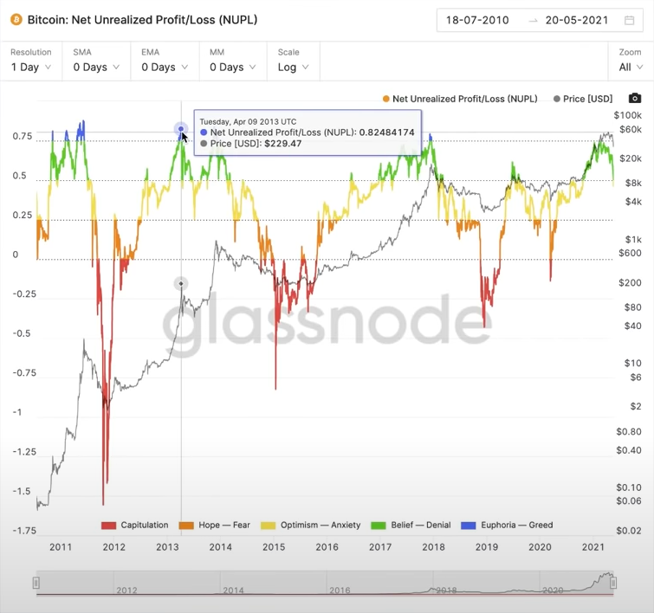

Block Chain Fundamentals

Block Chain

Staking
Staking is the process of actively participating in transaction validation on a Proof-Of-Stake block chain. Anyone with a minimum-required balance of a specific cryptocurrency can join a staking pool, validate transactions, and earn staking rewards on these blockchains.
When you stake cryptocurrency, you are participating in the validation of transactions. This is a similar process to the mining we see on proof-of-work (PoW) blockchains (without the mining hardware!) Staking is a new type of consensus mechanism on the PoS blockchain. A user can stake their money on such a network to validate nodes or transactions. When users do this, they receive the coins as rewards.
When staking, the number of coins “locked” inside a user’s wallet determines their right to validate transactions. Just like with mining, the goal is to add new transactions and blocks to the blockchain. In addition to the incentives for stakers, the scalability and high transaction speeds of PoS blockchains serve as other major benefits.

How does staking crypto work?
When a user decides to stake tokens in a PoS blockchain, they will need to have a balance in their wallet. The balance should meet that network’s minimum requirement. The node will stake that currency by depositing it into the network. This works similarly to a traditional security deposit.
How much has been staked is directly proportional to the likelihood that your node will be able to cast the next block. Therefore, the more a user stakes on the network, the potential there is for higher staking reward rates.
Just as a miner would get a reward on a proof-of-work chain, when a node successfully completes a block, the user who has helped validate that transaction receives a reward.
Like many other passive income methods, staking has some downsides are risks. Staking is an activity that’s unique to crypto assets. One risk to keep in mind is possible attempts to double-sign or attack the network. If such attacks happen, they will result in the user losing part of their stake. Another downside of staking is the lockup periods. If you want easy access to your funds and assets at all times, lockup periods are something to be aware of.

Where can I stake crypto?
Coins can be staked through cryptocurrency wallets, be it through major exchanges like Binance or Coinbase, or in the form of ‘cold staking’ on offline and private wallets. If cold staking, a user must keep their staked coins in the same address as moving them can break up the lock-up period. This can have the unintended consequence of a user losing their earned staking rewards. Notable cold storage wallets include Ledger, Trust Wallet, and Trezor, among others.
Coins can also be staked on what are known as Staking-as-a-Service Platforms. It is important that users familiarize themselves with the risks and rewards associated with these financial services. Above all, users should understand that these services will take a percentage of the earned rewards for services rendered. Ex: You can lock your stake-able coins in the earn wallet. You will receive rewards for locking for certain period of time. But, the returns you get are relatively less compared to what you get through wallet based staking or cold staking.

Proof of stake

Proof of work

Ledgers

Smart Contracts
Its like a kickstarter platform. It’s a computer program that executes when a set of conditions defined by the creator of the contract are met. A smart contract is an agreement between two people in the form of computer code. They run on the blockchain, so they are stored on a public database and cannot be changed. The transactions that happen in a smart contract are processed by the blockchain, which means they can be sent automatically without a third party. This means there is no one to rely on! The transactions only happen when the conditions in the agreement are met — there is no third party, so there are no issues with trust. Smart contracts are automatically executed once the conditions of the agreement are met. This means there is no need for a third party, like a bank, a broker, or a government.

How Is This Possible?
As mentioned before, we have the blockchain to thank. Because of blockchain technology, we are able to decentralize smart contracts so that they are fair and trustless. By decentralizing, I mean that they are not controlled by one central party (like a bank, broker, or government, etc.).
The blockchain is a shared database run by many computers (called 'nodes') belonging to many different people. Because of this, not one single person or company has control of it.
It means it's near impossible to hack it — the hacker would need to hack more than half of the nodes if they wanted to attack the blockchain or the smart contracts that run on it. Therefore, smart contracts can run safely and automatically without anyone being able to change them! Now you know even more about what a smart contract is!

Applications
Can be implemented in various business applications.
- Insurance Companies: John is about to fly from NYC to Los Angeles. He sends $5 worth of cryptocurrency to the Axa Insurance smart contract and provides his flight number. Axa sends $95 to the smart contract. So, there is $100 in the smart contract. If John’s flight is on-time, Axa is sent $100 from the smart contract. But if the plane is late, $100 is sent to John from the smart contract. Everything is automatic. This saves lots of time and money. It also means that John does not have to trust that AXA will pay him the agreed amount if his flight is late — he knows that if it is late, the smart contract will instantly send him his compensation ($100).
- Health Systems: Health systems will use smart contracts to record and safely transfer data. We can already see examples of smart contracts being used in the medical industry by the likes of EncrypGen. This is an application that uses smart contracts to transfer patient data in a secure way, allowing no access from third parties. This way, the patients are in control of their own data. If researchers want to use patient data, they must pay for it. Not only that, but the patient has to choose whether or not they want to sell it to them.
- Governments: For governments, smart contracts running on the blockchain can make voting systems completely trustless and much more secure. Applications like FollowMyVote use smart contracts and blockchain technology to protect votes from fraud. When the voting transaction is written to the blockchain, it cannot be changed. When the voting is over, the smart contract will send a token to an address that represents the winner of the vote. This way, voting is always fair, meaning the winner is always correct.
One of the interesting application is using the smart contracts with arbitrage to take advantage of the price difference in difference exchanges and also with trading bots when the coin/token reaches low to high (pump and dump schemes).
- Arbitrage Trading: You can use this to buy some coins of the exchange for the some price, then transfer the coins to another exchange where the price of the same coin is higher than the exchange where you bought the coins, then sell it there. This sounds attractive but with all the commissions and fee involved, you wouldn’t be profitable unless you trade with high capital. That’s when the smart contracts will come into play. I haven’t done extensive research on this but in theory what professional traders do is they get a smart contract which has the program to borrow flash loans, then the smart contract has a condition to buy and sell the coins from exchange A to exchange B there by making some profit. Then releasing the borrowed loan back to the lender. Normally, you use automated bot in association with smart contracts to make profits. Remember, there is lot of things you need to factor in when you do arbitrage. It is not fully automated, you need to also monitor the script and make sure it wont go unprofitable.
- Trading Bot: Similar to the flash loans explained in the above arbitrage topic, you will borrow loan into the smart contract and define conditions on a certain coin that you want to trade. So, the smart contract will execute only when the coin price will reach a certain price you defined and hence you can get the profit and you reimburse the borrowed loan back to the lender.

Distributed Ledgers

Decentralized Apps

ERC20 Tokens

Adding Liquidity

Front Running in Ethereum

Decentralized Exchanges
- ETH chain
- Binance chain
- Matic chain
- Fantom chain

Centralized Apps

Scalability of transactions

Wallets

Coins vs Tokens

Gas fee

Fiat Money

Coin Fundamentals

Bitcoin (BTC)

Ethereum (ETH)

Cardano (ADA)
- Cardano overcomes all the pain points of the blockchain protocols involved in BTC and ETH.
- It is developed by IOHIK (Input Output Hong Kong) company.
- It solves ‘scalability of transactions’ issue in BTC. And bugs stemming from Solidity programming language used to create ETH.
- It provides a platform to execute smart contracts and to develop and run decentralized applications more efficiently.
- Other features include
  - Launching side chains
  - Multi party computation
  - Metadata
- The protocol itself launched on September 29th, 2017, after two years of rigorous research and development by a robust community of academics comprising of the world’s leading scientists, cryptographers, and researchers.
- The aspect of Cardano’s peer-reviewed development process differentiates itself heavily from other blockchains.
- Cardano is still undervalued with its price because it solves many problems creatively and efficiently.
- Following are the powerful features of ADA.
  - Interoperability
    - Exchanging BTC to ETH cannot be executed without an intermediary yet.
    - ADA aims to make a blockchain that can communicate with other blockchains.
    - In addition, there can be metadata attached to each transaction, but it should be rightfully up to the user on whether or not that data will be publicly made available.
  - Scalability
  - Sustainable Development
- Quotes
  - “Cardano does not try to be the Columbus of cryptocurrencies. It tries to be the ocean that will take Columbus to the land”- CryptoBasic

Polygon (MATIC)
- It’s a token and not a coin. Built on Ethereum blockchain.
- It is a protocol and a framework for building and connecting ETH compatible blockchain networks.
- Scaling is achieved by two ways. Layer 2 and Side Chains. Layer 2 is the second layer on top of ETH blockchain and relies on ETH security model. Whereas, Side Chain is independent scaling mechanism and have their own security model ‘Plasma Network’ and a decentralized network of Proof Of Stake.
- Layer 2 implementations – Matic Plasma, zK Rollups, Optimistic Rollups, Validum Chains.
- Side Chains – technically apart from ETH ecosystem which provides its own security, its independent, flexible. Give you lot of customization capabilities. You can add/extend features. You can use this to make your own blockchain may be only side in your company sort of a private blockchain.
- Matic Network is an ​off/side chain scaling solution for existing platforms to provide scalability and superior user experience to DApps/user functionalities.
- Polygon tries to make ETH gas fee lower. It aims to improve scalability for blockchains especially ETH’s scalability problem.
- If you want to get around the high ETH transfer gas fee, you can use Polygon
- Polygon supports
- Headquartered in New Delhi, India.
- Their competitive positioning
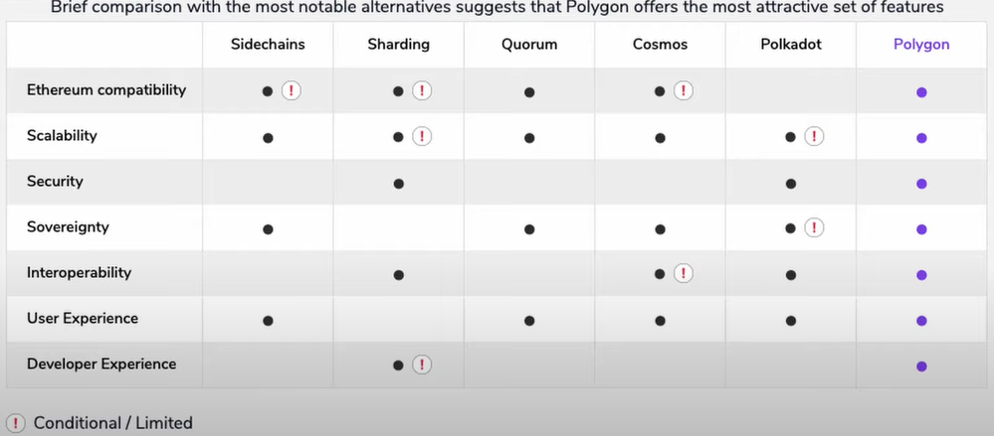

Key Features & Highlights
- Scalability: Fast, low-cost and secure transactions on Matic sidechains with finality achieved on mainchain and Ethereum as the first compatible Layer 1 basechain
- High Throughput: Achieved up to 10,000 TPS on a single sidechain on internal testnet; Multiple chains to be added for horizontal scaling
- User Experience: Smooth UX and developer abstraction from mainchain to Matic chain; native mobile apps and SDK with WalletConnect support
- Security: Matic chain operators are themselves stakers in the PoS system
- Public Sidechains: Matic sidechains are public in nature (vs. individual DApp chains), permissionless and capable of supporting multiple protocols.

My final thoughts
- Well. ETH is set to release v2.0 which constitutes Proof Of Stake protocol, increasing the scalability, sharding which is destined to lower the gas fee due to conversion of POW to POS in the future. But still Polygon ecosystem is huge which offers a ton of framework features. Even if its dominance goes down when ETH v2.0 is released, Polygon already has other framework features as discussed above. Its for sure a long term bet.
- Polygon team is ambitious and very optimistic to bring out many features in Crypto market in future.
- Also, off the records, Vitalik Buterin (Founder of ETH) donated 1 Billion Dollars to Polygon founder on account of India Covid Release fund. As you might know who politics works in India, the partial donation money may into company’s funding. This means they for sure have a big plans to grow Polygon as a company in coming years.
- Its definitely is a good investment for long term.

